Downtown Bench Donation Application and Financial Agreement

DONOR INFORMATION:
Applicant/Donor Name: ____________________________________________________

Mailing Address: _____________________________________________________________________

Phone: _________________________ Cell: ______________________ Email: ____________________

DONATION ITEM & LOCATION INFORMATION: Benches will be placed in a designated location in downtown Enumclaw (Cole Street and one block of Griffin near Cole Street). You will be notified of your bench’s location.

PLAQUE VERBIAGE (limited to 4 lines, 20 characters per line including spaces):

___________________________________________________________________________________

___________________________________________________________________________________

___________________________________________________________________________________

DONOR/APPLICANT STATEMENT:
I, __________________________ (Name), have read and agree to the City of Enumclaw’s Park Donation and Memorials in Parks Policy. I agree to the pricing set forth by the pricing guide and will pay in full at the time my application is approved.

DONOR/APPLICANT SIGNATURE: ______________________________________________________________

DATE: _______________________________

BENCH DONATION AND PRICING GUIDE

BENCH WITH MEMORIAL PLAQUE:

A 6 foot steel bench with back, decorative cast iron rosettes, flat bar steel seat bed welded into one unit, cast iron supports, stainless steel fasteners, black powder coat. Includes a memorial plaque.

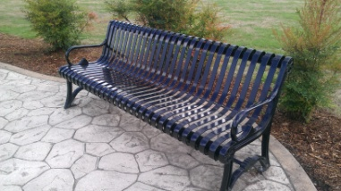
Bench Cost: $2,000

Quantity | Cost

